Record Silo Fill Levels in Real Time Thanks to Sensor-to-Cloud
Adfil's smart level detection system from Turck, which optimizes procurement and production at the same time, demonstrates how sensor-2-cloud solutions don't have to be expensive and complex

In many production sites, the correct supply of materials is critical in order to ensure optimum production processes. This is also the case for Belgian plastics specialists Adfil, for which Turck Multiprox implemented a smart sensor-2-cloud solution that enables procurement and production to access real-time data on silo levels at any time. This ensures that the right quantity of raw materials is always available.

With more than three decades of experience, Adfil is a proven specialist in the development and manufacture of synthetic fibers for concrete reinforcement. The company, headquartered in Zele, Belgium, produces the synthetic fibers in different variants for ready-mix, precast or sprayed concrete. Adfil specialists in the company's planning office determine the exact amount of fiber for the particular concrete, which is used in a wide range of applications, from concrete floors and paving, tunnel linings, right through to precast concrete for walls or fences.

Reducing the ecological footprint
Choosing synthetically reinforced concrete is also a good move in terms of sustainability and reducing the carbon footprint. Independent studies prove that 90% of the carbon can be saved in the reinforcement through the use of this fiber. Besides the fact that no steel is required, the considerable reduction in vehicle movements – by eliminating the need to transport steel mesh – has a positive effect on the carbon footprint.

With smaller loads, it was thus very likely that the level of certain granulates was not measured frequently enough and there was a risk of production stops due to raw material shortage. There was no continuous level measurement. For this reason, Guy De Vuyst, maintenance engineer at Adfil, decided to automate it. The search for accurate and inexpensive sensors was a challenge at first. Although special solutions were available, they were more expensive than the planned budget.

Continuous level measurement using laser sensors
Not so with the solution from Turck Multiprox. Turck's Belgian subsidiary could offer a solution that was not only attractive in terms of price: the LTF12 laser sensor from Turck's optical sensor partner Banner Engineering. This laser sensor with an IO-Link output has a range of up to 12 m with a resolution of 0.3 to 3 mm. The sensor's measurements remain accurate and reliable over long periods of time. Unlike with other sensors, the lenses of the LTF12 make it ideal for this application as they do not require high pressure cleaning to ensure correct measurements.

However, the actual added value of the offer from Turck Multiprox was the fact that they developed a flexible complete solution. They therefore not only provided support in selecting the most suitable hardware, but also in configuring the components and programming certain parts of the code. The IO-Link sensors were connected to Turck's FEN20-4IOL, one of the most compact IO-Link masters on the market. This multiprotocol I/O station with four IO-Link master channels also offers optimum flexibility as it can be used as an EtherNet/IP slave, Modbus TCP slave and c slave. The IO-Link masters are connected to a Siemens PLC via Profinet. From there, the data is visualized locally on the HMIs in WinCC. The data is also forwarded to the Ignition SCADA via OPC UA.

Sensor-2-cloud solution supports procurement
It was also important for Adfil's purchasing department to be able to act quickly and correctly based on the measurement data, even if they were not on site. Deliveries to the production plant that are too fast can lead to overfilling in one of the silos. Too slow a supply may lead to material shortage and even a production stoppage in the worst case. For this, Turck Multiprox has developed a cloud solution that gives both the coworkers in the purchasing department as well as those in production an overview of the correct level of each silo at any time.

The Turck TX700 dual-core IoT gateway with the Codesys V3 controller is used here to read the IO-Link islands simultaneously via Modbus/TCP. The TX700 is a genuine 'Swiss Army knife' piece of equipment that offers a host of communication, visualization and programming options. The device is future-proof and fits perfectly in the Industry 4.0 strategy of modern companies.

Conclusion
As the example shows, even the digitalization of a relatively simple task can bring enormous gains in efficiency. With this clearly manageable and attractively priced IIoT application, Adfil now benefits from measurement data that can be accessed continuously from anywhere, thus enabling optimized procurement and production processes. As Guy De Vuyst also confirms: “We are very pleased with the solution from Turck Multiprox. This very reasonably priced solution allows our coworkers in purchasing and production to monitor the granulate levels in our silos so that supply is always exactly matched to our needs.”

Author
Hans De Craemer is marketing manager at Turck Mutliprox in Belgium

((Quote))
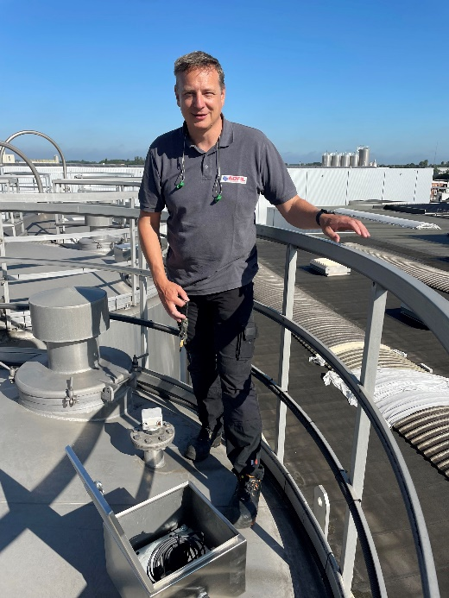
Adfil_02:
“We are very pleased with the solution from Turck Multiprox.”
Guy De Vuyst, Adfil

((Images))
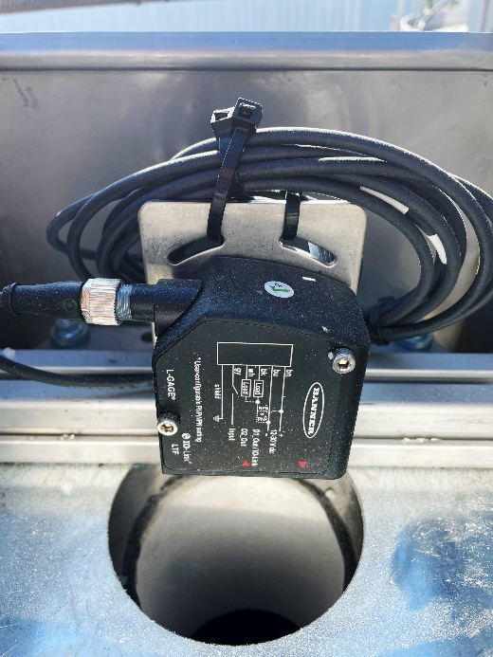
Adfil_01: The LTF12 laser sensor has a range of up to 12 m with a resolution of 0.3 to 3 mm

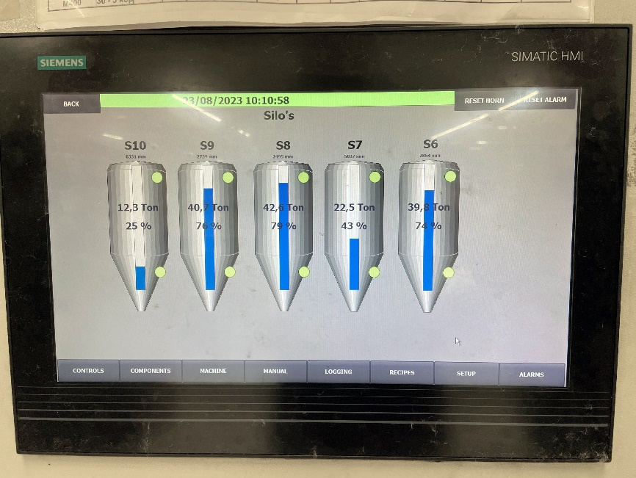
Adfil_03: The silo levels are displayed from the cloud on the monitor in real time

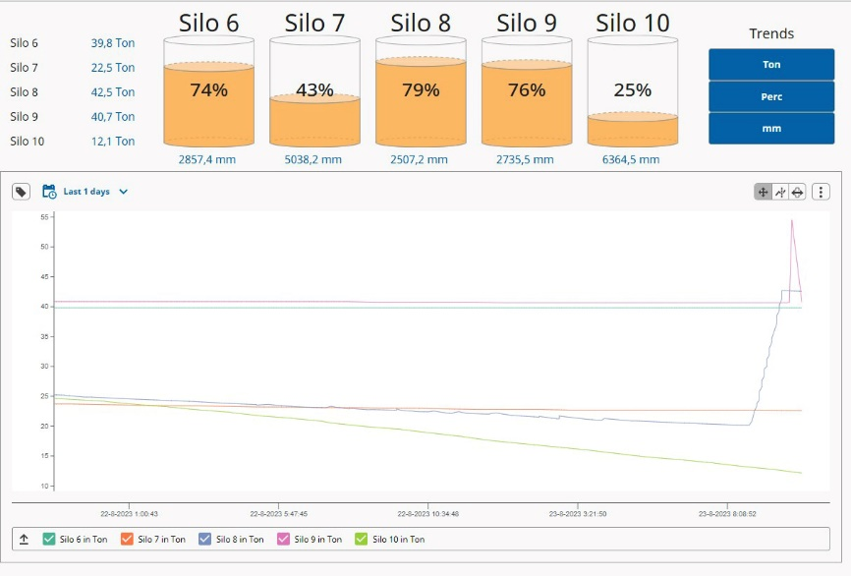
Adfil_04: The purchasing department can view the levels in the Scada system at any time and can order in good time

PRESSE-KONTAKT
Klaus Albers
Leiter Marketing Services & Public Relations
Telefon: 0208 4952-149
Mobil: 0160 93950359
Mail: klaus.albers@turck.com
Web: www.turck.com/presse

LESER-KONTAKT
Hans Turck GmbH & Co.KG
Witzlebenstraße 7
45472 Mülheim an der Ruhr
Telefon: 0208 4952-0
Mail: more@turck.com
Web: www.turck.com

